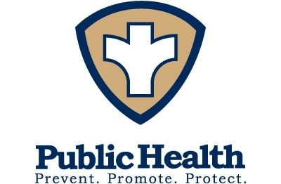
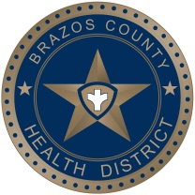
Intern, Practicum, & Volunteer Experience Guidelines
- Students interested in a practicum opportunity at the Brazos County Health District should send an email to healthdept@brazoscountytx.gov that includes the following:
  - Resume
  - Completed application (located on our website-www.brazoshealth.org)

- Resume and application must be submitted by the following days:
Fall Practicum: June 1
Spring Practicum: November 1
Summer Practicum: March 1

- Students will be contacted by a staff member by the following days:
Fall Practicum: June 14
Spring Practicum: November 14
Summer Practicum: March 14

- Due to staff availability, BCHD is limited to the number of practicum students that can be accepted. The number varies each semester, so submitting your application early is recommended.

- All opportunities are uncompensated positions.

